Technology Stack
ShopEZ — MERN Stack E-commerce Application

Phase: Requirement Analysis Phase
TEAM ID : SWUID2026207177

Classification: Project Documentation — For Academic Submission
Technology Stack
1
. Introduction
This document provides a formal specification of the technology stack selected for the ShopEZ platform. Each technology selection is accompanied by its architectural role, justification, and a brief Architecture Decision Record (ADR) summarising the decision rationale and alternatives considered.
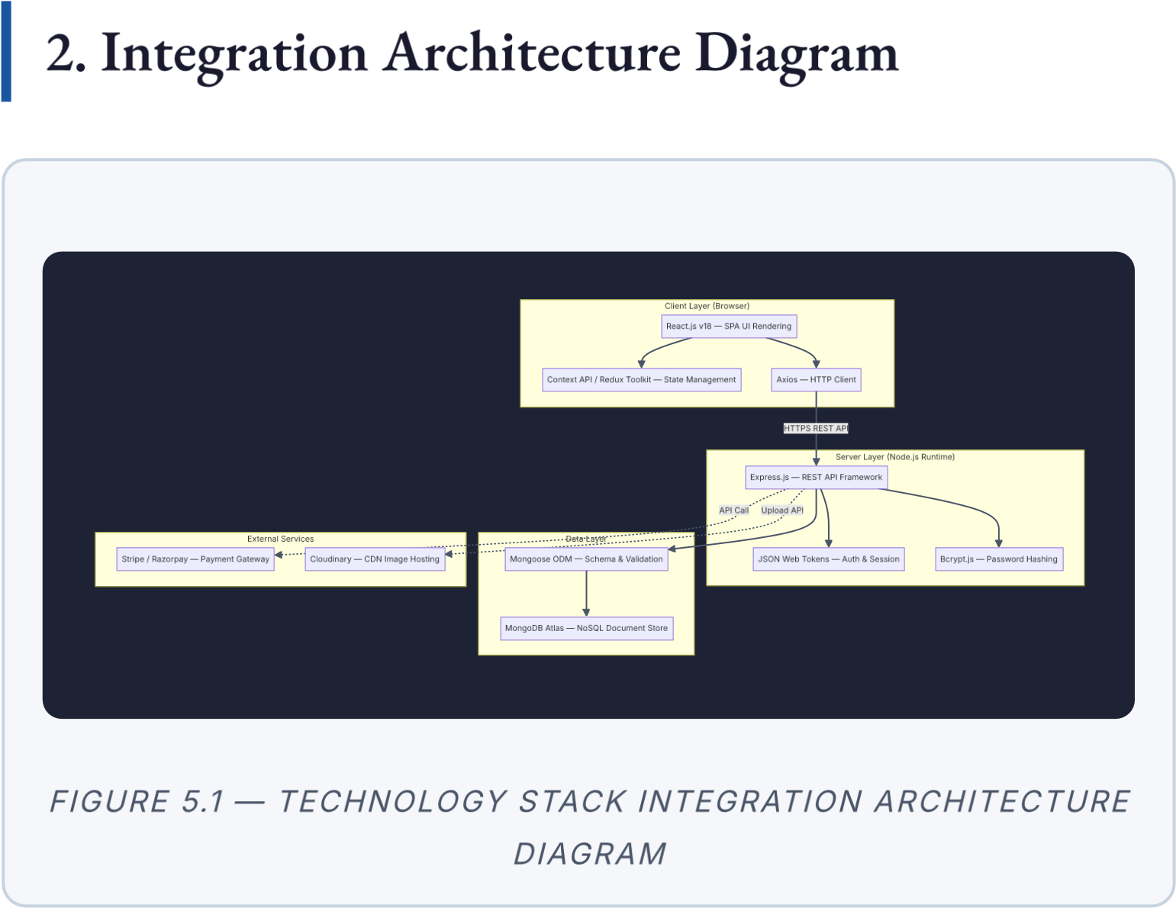

3. Detailed Stack Breakdown
Layer | Technology | Version | Purpose & Justification
Frontend React.js v18.x Component-driven SPA
Framework architecture. Virtual DOM
ensures efficient, targeted UI re-rendering. Hooks-based API enables clean functional component design.
State  Management | Context API /  Redux  Toolkit | v2.x | Centralised global state for authentication context, shopping cart, and cached API data. Redux Toolkit reduces boilerplate via createSlice .
HTTP Client Axios v1.x Promise-based HTTP
client with request/response interceptors, automatic JSON serialisation, and configurable base URL.
Preferred over native fetch for interceptor support.
Backend  Runtime | Node.js | v18 LTS | JavaScript runtime enabling full-stack single-language development. Nonblocking, event-driven I/O suits concurrent API request handling.
Backend Express.js v4.x Minimal, unopinionated
Framework framework providing
Layer | Technology | Version | Purpose & Justification
robust middleware composition, route parameterisation, and structured error handling for RESTful APIs.
Authentication | JSON Web  Tokens  (JWT) | RFC  7519 | Stateless, self-contained bearer tokens signed with a server secret. Stored in HTTP-only cookies to mitigate XSS. Enables horizontal API scaling without shared session storage.
Password Bcrypt.js v5.x Industry-standard
Security adaptive hashing (salt
rounds ≥ 10). Applied via
Mongoose pre-save hook on the User model.
Database | MongoDB  (Atlas) | v6.x | Document-oriented  NoSQL store for flexible schema design. Hosted on Atlas for managed backups and autoscaling.
ODM Mongoose v8.x Schema-based ODM
providing validation, type enforcement, virtual fields, populate references, and lifecycle hooks.

Layer |  | Technology | Version | Purpose & Justification
Payment  Gateway |  | Stripe /  Razorpay | Latest | PCI-DSS compliant payment APIs. No sensitive financial data stored on the ShopEZ server.
 | Media Hosting | Cloudinary | v2.x  SDK | Provides automatic image compression, WebP
conversion, and CDN delivery. Eliminates local filesystem dependency.
Deployment | Vercel (FE) /  Render (BE) | — | Vercel provides React deployment with global CDN edge caching. Render hosts Node.js API with auto-deploy on Git push.

4. Architecture Decision Records (ADRs) ADR-01: MongoDB over Relational Database
Field | Detail
Status | ✅ Accepted
Context | The product catalogue requires a flexible schema — product attributes vary significantly across categories.
Decision Adopt MongoDB as the primary data store.
Justification | Document-based storage natively accommodates variable product attributes without migration-heavy ALTER TABLE operations.
Consequences No multi-document ACID transactions by default. Mitigated by Mongoose document-level atomicity for order creation and stock deduction.

ADR-02: JWT in HTTP-only Cookies over localStorage
Field | Detail
Status | ✅ Accepted
Decision | Store JWT in HTTP-only, SameSite=Strict cookies rather than localStorage .
Justification localStorage is fully accessible by JavaScript, making it vulnerable to XSS. HTTP-only cookies are inaccessible to client-side scripts.
Consequences | CSRF mitigation required via SameSite=Strict attribute and CORS configuration.

ADR-03: Cloudinary over Local File Storage
Field | Detail
Status | ✅ Accepted
Decision | Use Cloudinary's cloud image management platform.
Justification | Provides automatic resizing, WebP conversion, and global CDN. Eliminates reliance on application server's ephemeral filesystem (Render).
Consequences | External API dependency and storage cost. Mitigated by enforcing file size limits in upload middleware.

ShopEZ MERN E-commerce Application · Requirement Analysis Phase · Technology
Stack · v1.1 · June 2026

